Summer Book Bingo Grades K-2
Earn BINGO by completing tasks in the boxes and having a parent or grown-up sign the completed boxes.
5 in a row is BINGO! Complete the whole card, EVERY BOX, and you have SUPER BINGO!
Bring your completed BINGO card back to school in the fall. Mrs. Johnson will celebrate your reading with a prize! Students with SUPER BINGO cards will be invited to a reading celebration party!

B | I | N | G | O
Check out a book from the library and read it!   | Have a reading picnic with someone- bring a book and read it together!   | Read to a pet or stuffed animal!   | Read two books by the Eric Carle!  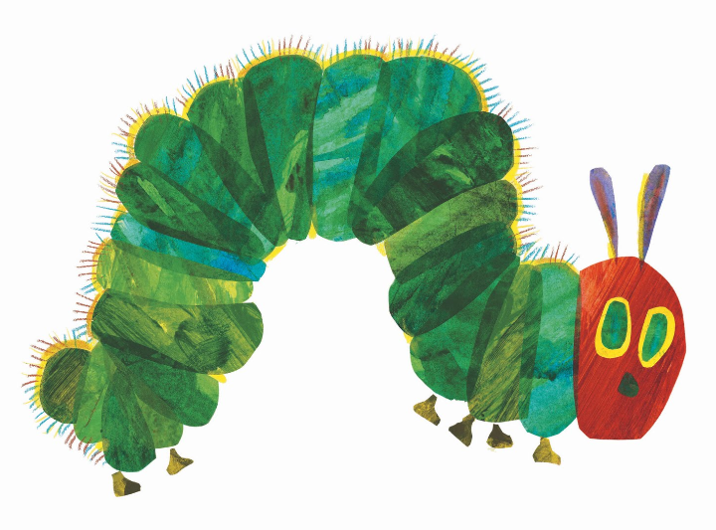 | Read a book out loud just like a teacher!  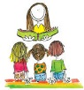
Read a book about an animal  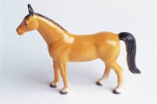 | Read a book that rhymes | Read a book that has something to do with the sky or space!@   | Write and illustrate your own story! |   Reread your favorite book of all time!
Read Outside  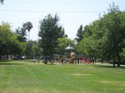 | Read a magazine | Use the log of all the books you have read this summer. Your log must be turned in with your Bingo Board. | Read a book about a real person!  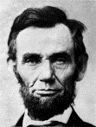 | Read a fable, folktale, or fairy tale!  
Read a chapter book with an adult or grown-up!  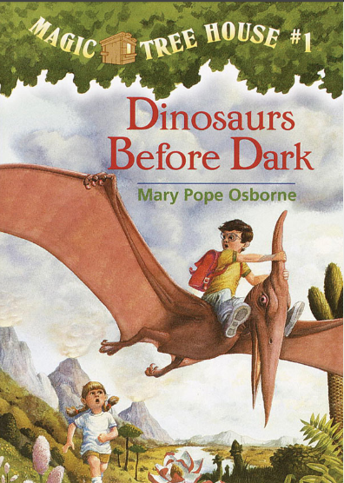 | Read under a blanket with a flashlight!  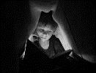 | Read poems from a poetry book!  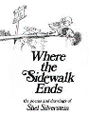 | Read to someone older than you!   | Read an award winning book  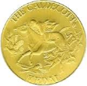
Read a wordless picture book  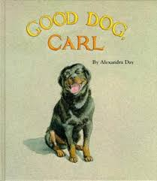 | Read a nonfiction book   |   Be creative! Read in a totally new place-under a table, in the bathtub, under a tree! | Read a silly book! | Write a postcard to Mrs. Johnson about a book you read and loved!  Mrs. Johnson-VMES  11711 Joseph Mill Rd.  Silver Spring, MD 20906

