Summer Book Bingo Grades 3-5
Earn BINGO by completing tasks in the boxes and having a parent or grown-up sign the completed boxes.
5 in a row is BINGO! Complete the whole card, EVERY BOX, and you have SUPER BINGO!
Bring your completed BINGO card back to school in the fall. Mrs. Johnson will celebrate your reading with a prize! Students with SUPER BINGO cards will be invited to a reading celebration treat party!

B | I | N | G | O
Check out a book from the library and read it!   | Have a reading picnic with someone- bring a book and read it together!   | Read to a pet or stuffed animal!   | Read two books by the same author!   | Read a fantasy book!  
Read a non-fiction  book about SCIENCE!   | Read a book about history!   | Read a non-fiction book about space!   | Write and illustrate your own story! | Read a graphic novel!  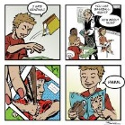
Read outside!  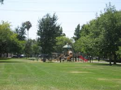 | Read a magazine! | Make a log of all the books you have read this summer. Your log must be turned in with your Bingo Board. | Read a biography!  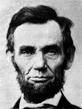 | Read a fable, folktale, or fairy tale!  
Read an entire chapter out loud just like a teacher!  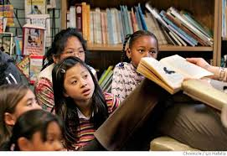 | 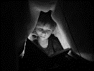  Read under a blanket with a flashlight! | Read poems from a poetry book!  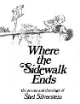 | Read to someone younger than you!   | Read an award winning book!  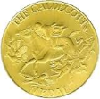
Reread your favorite book of all time!   | Read in bed  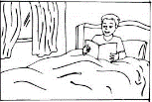 |   Be creative! Read in a totally new place; under a table,  in the bathtub,  under a tree! | Read a silly book | Write a postcard to Mrs. Johnson about a book you read and loved!  Mrs. Johnson-VMES  11711 Joseph Mill Rd.  Silver Spring, MD 20906

